1. select \*

from emp;

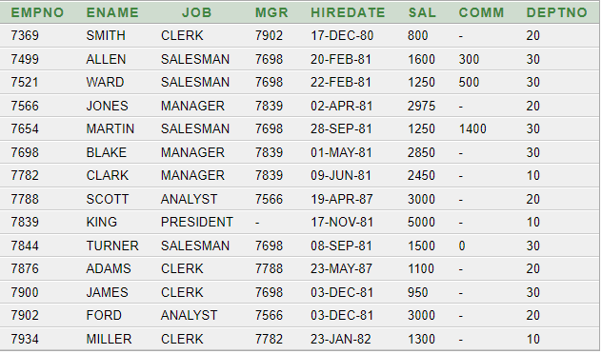

1. select empno, ename

from emp;

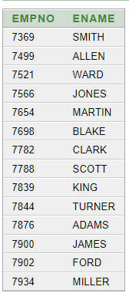

1. select empno, ename as NAME

from emp;

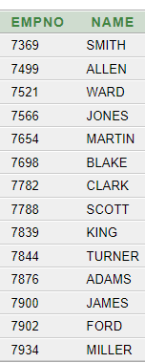

1. select ename, sal, sal\*12 as "Yearly Salary"

from emp;

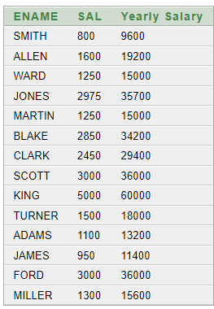

1. select empno || ename INFO

from emp;

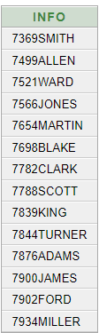

1. select 'id ' || empno || ' ' || 'name: ' || ename INFO

from emp;

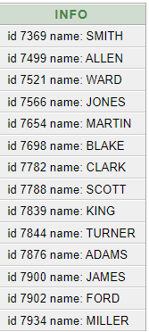

1. select empno, ename, sal+comm

from emp

where ename = 'SMITH';

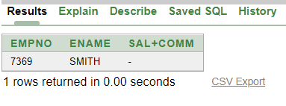

1. select distinct deptno

from emp;

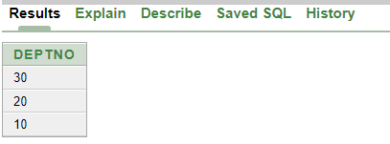

1. desc emp;

